
DEPARTMENT OF

COMPUTER SCIENCE & ENGINEERING

Experiment 1
Student Name: Rohit Yadav UID: 23BAI70628
Branch: AIT_CSE Section/Group: 23AIT_KRG_G2
Semester: 6th Date of Performance:
Subject Name: Full Stack II Subject Code: 23CSH-382

- Aim:

To design and develop a web-based Environmental Impact Tracker (EcoTrack) that calculates and categorizes carbon footprint based on different daily activities using ReactJS.

- Objective:

The main objectives of this experiment are:
- To understand the use of React components for UI development
- To calculate total carbon footprint using JavaScript logic
- To classify activities into High Carbon and Low Carbon emissions
- To design a minimalist and user-friendly dashboard UI
- To improve understanding of arrays, filter, reduce, and conditional rendering

- Implementation/Code:

=>App.jsx

import './App.css'
import Dashboard from './Pages/dashboard.jsx';
import Logos from './Pages/logos.jsx';
import Low from './Pages/low.jsx';
const App=()=>{
return(
<div>
<h1 style={{background:"green",color:"white"}}>EcoTrack</h1>
<Dashboard/>
<Logos/>
<Low/>
</div>)
};
export default App;
=>logs.js

const logs = [
{ id: 1, activity: "Car Travel", carbon: 4 },
{ id: 2, activity: "Electricity Usage", carbon: 6 },
{ id: 3, activity: "Cycling", carbon: 0 },
{ id: 4, activity: "Bus Travel", carbon: 3 },
{ id: 5, activity: "Solar Energy Usage", carbon: 1 },
{ id: 6, activity: "Flight Travel", carbon: 8 },
];

export default logs;

=>dashboard.jsx

import logs from "./logs.js";
const Dashboard=()=>{
const totalCarbon=logs.reduce((sum,log)=>sum+log.carbon,0)

return(
<div>
<h2>Dashboard</h2>
<p>Total Carbon FootPrint: {totalCarbon} kg CO2</p>
<ul>
{
logs.map((log)=>(
<li key={log.id}>
{log.activity}= {log.carbon} kg CO2
</li>

))
}
</ul>
</div>
)};
export default Dashboard;

=>logos.jsx

import logs from "./logs.js";
const Logos=()=>{
return(
<div>
<h2 >High Carbon Emission</h2>
<ul id="high">
{
logs.filter((log)=>log.carbon>=4).map((log)=>(
<li key={log.id}>
{log.activity}={log.carbon}
</li>
))
}
</ul>
</div>
)};
export default Logos;
________________________________________
=>low.jsx

import logs from "./logs.js";
const Low=()=>{
return(
<div>
<h2 >Low Carbon Emission</h2>
<ul id="low">
{
logs.filter((log)=>log.carbon<4).map((log)=>(
<li key={log.id}>
{log.activity}={log.carbon}
</li>))}
</ul>
</div>
)
};
export default Low;

________________________________________

- Output

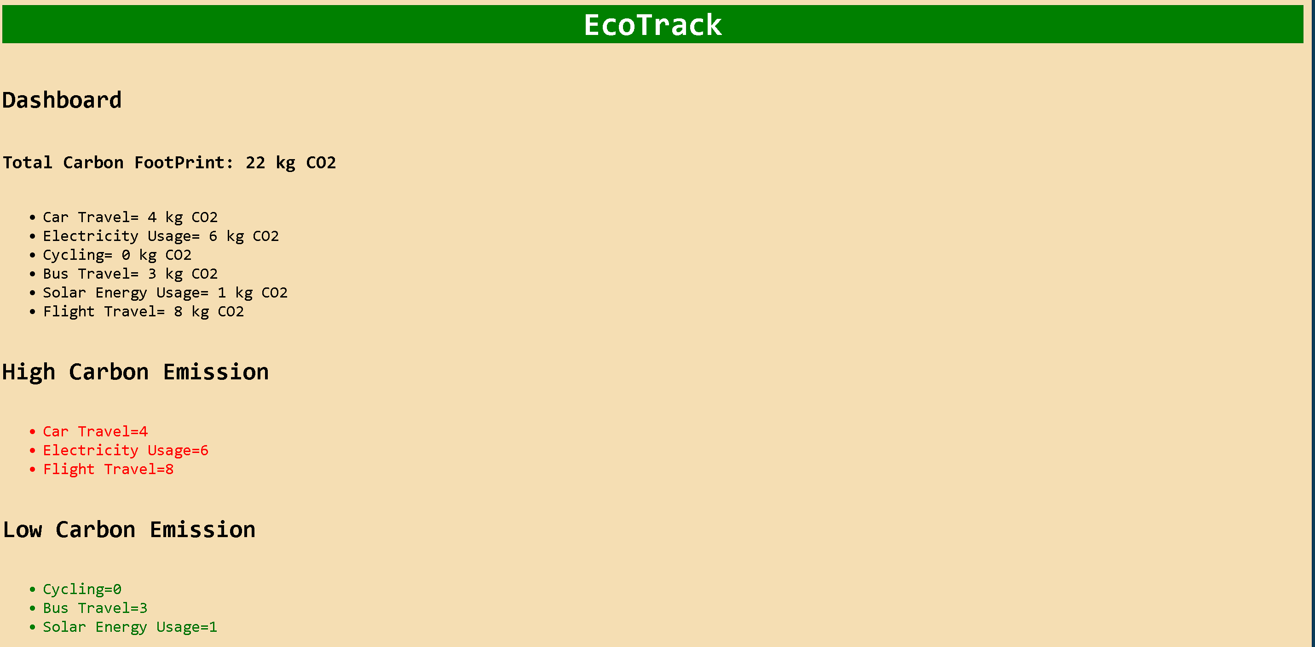
- Learning Outcome
• How to build reusable UI using React components
• Practical use of map(), filter(), and reduce()
• How to manage and display data dynamically in React
• Basics of dashboard UI design with CSS
• Understanding of environmental impact awareness through technology

